Indian Institute of Information Technology, Allahabad
Multi Featured Online Media Player with Multicasting,Videoconferencing and Streaming Capabilities
Project Report

Submitted by:
Rahul Budhiraja Manish Kumar
IIT2006098 IIT2006039
iit2006098@iita.ac.in mani.iiita@gmail.com

Under The supervision of :Prof.G.C.Nandi

Candidates' Declaration
I hereby declare that the work presented in this project proposal entitled "Multi-featured Online Media Player with Mulitcasting,Video Conferencing and Streaming Capabilities" submitted towards compilation of VIIth semester project of B.Tech (IT) at the Indian Institute of Information Technology, Allahabad, is an authentic record of our original work being carried out under the guidance of Dr.G.C.Nandi, Allahabad. The project will be done in full compliance with the requirements and constraints of prescribe curriculum and a complete report will be submitted before end semester evaluation.

Place: Allahabad Rahul Budhiraja Manish Kumar

Date: 30-09-2009 IIT2006098 IIT2006039

Certificate
This is to certify that the project work entitled " Multi-featured Online Media Player with Mulitcasting,Video Conferencing and Streaming Capabilities " is being carried out for compilation of 7th semester project of B.Tech(lT) at IIIT, Allahabad. The above declaration made by the candidate is correct to the best of my knowledge and belief.
Place: Allahabad Dr.G.C.Nandi
Date: 04-12-2009 IIIT ALLAHABAD

Contents

- Topic………..…………………………………………………………5
- Motivation.. .............. 5
- Applications.............. .................5
- Theory.................... .................6
- Architecture.…………………………………………………...…7
Level Wise Distribution …………………………….. 7
- Work Plan… ……………………………………………………....8
Work done before Mid semester..................................8
Work Done After Mid Semester....................................9
Possible Future Extensions ………………………………………..9
- References……………………………………………………………10
- Comments of the Evaluation Board………………………………….11

1. Topic
The project aims to build a Multi-Featured Online Media Player with multiple capabilities such as Video Conferencing, Multicasting, Live Streaming of Videos and to build a Digital Repository and constructing an efficient interface for the user-client Interaction With Valid User Authorization.

2. Motivation
With The Advent of Flash Media Server, the features of Video Conferencing And Multi Casting have become much Easier and usability of these features in an application has greatly increased.
Even though many softwares are available on the internet for Multicasting or Designing A media Player with some controlling functionality, Developing An Integrated Player with all the functionalities and making it open source solely for the purpose of usage within IIIT Campus has been the primary aim of this project
This Player has been designed by taking into consideration the features required in a media player plus common functionalities provided by an online video conferencing application.

3. Applications

Government And Administration

The Government can Easily connect with and inform citizens, businesses, and other agencies, even while budgets are tightening. Whether it’s through real-time training, live event broadcasts, or simple video streaming, The Flash Media Server can help you enrich the business of government

- Education
Delivers a smooth streaming experience on our campus with Flash Media Server software. Easy out-of-the-box implementation and the ubiquity of Flash Player provide a seamless solution for communications — from journalism to training, from sports to student government.

Social media
We can build innovative, profitable social media applications with Flash Media Server software. Enhanced features like chat, bugs, and VoIP make our service interactive and engaging without requiring downloads of additional software.

4.Theory
- Technologies used
Flash Media Server,PHP,Actionscript,Flash,Photoshop,Apache Server Foundation,RTMP Protocol

- Descriptions

RTMP Protocol

Real Time Messaging Protocol (RTMP) is a proprietary protocol developed by Adobe Systems for streaming audio, video and data over the Internet, between a Flash player and a server.

The RTMP protocol has three variations:
The "plain" protocol which works on top of TCP and uses port number 1935
RTMPT which is encapsulated within HTTP requests to traverse firewalls.
RTMPS which works just like RTMPT, but over a secure HTTPS connection.

Flash Media Server

Flash Media Server has supported live video and audio streaming. Adding Flash Media Live Encoder for encoding live web broadcasts offers two important benefits over the DV encoding which is used by handycams: the highest quality video supported, and quicker, easier deployment.

Flash Media Live Encoder directly delivers the highest quality supported video by using On2 VP6 encoding. Previously, this was only possible through the use of third-party solutions. Flash Media Live Encoder provides quicker, easier deployment by being a fully featured acquisition and encoding application that natively integrates with Flash Media Server. Previously, the acquisition and encoding functionality had to be custom-coded using the Flash authoring tool.

5.Architecture
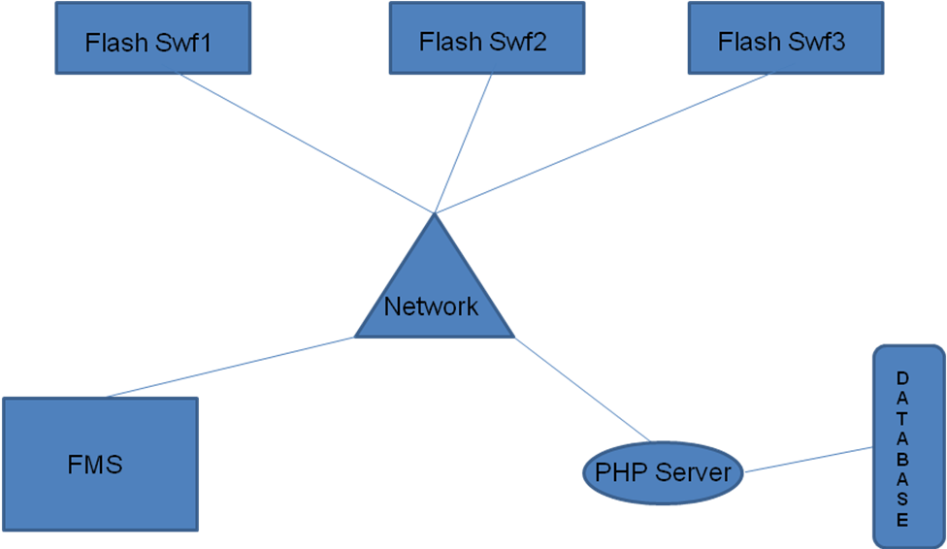
Level Wise Distribution

After effects &Photoshop - level 1
Flash – level 2
Action Scripting - level 3
Flash media server - level 4

Level 1:

The design of the player in Photoshop and the effects which shall be a part of the buttons of the player are implemented in this phase . The button animations are exported as an FLV and the design is exported as a JPEG image to Flash.

Level 2:
Flash integrates the design of the player with the button effects applied to it . The buttons are animated in sync with their respective swf’s using tweener.

Level 3:
Actionsrcipting for performing functions like playing video , screen capturing etc.. is done to the flash document from below level.

Level 4:
Communication between two flash files using Flashmedia server technologies and facility of broadcasting, online streaming etc… is handled in this level.
6.Work Plan
- Work done Before Mid Semester
l.A customized player with the help of Photoshop has been built with customized buttons
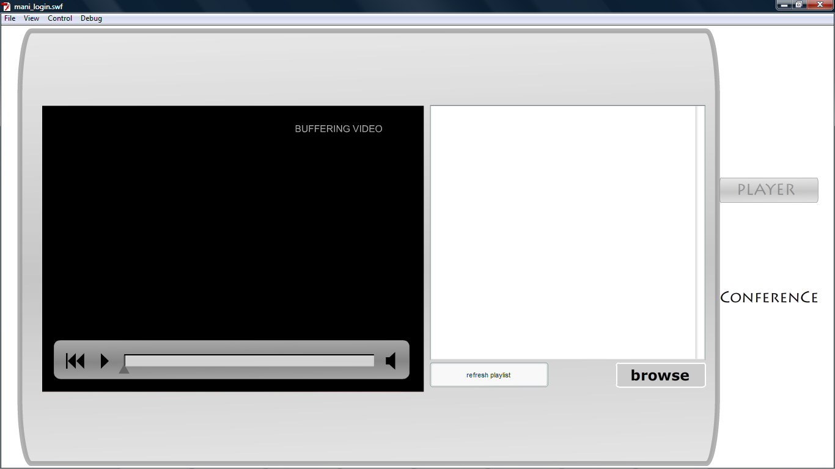
2.The Animations of the buttons and linking the playlist with relevant Actionscripting has been done.
3.The Digital Repository on both the client and the server side has been built and Functionalities such as uploading files to server have been implemented
4. The Broadcasting Feature of the player has been implemented but it is yet to be integrated with the player.
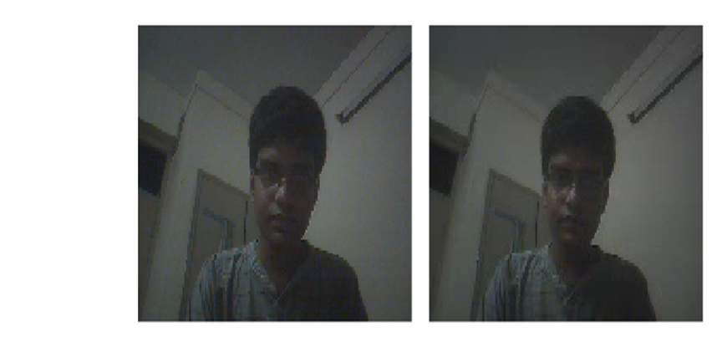

- Work Pending for End Semester
1.Implementation of User Authorization/profiling
2.Linking this Profiling with the functionalities like Digital repository,Multicasting, multimedia chat etc..
3.Providing space and video sharing among users along with other security features
4.Video Conferencing and multimedia chat between 2 or more clients.
5.Integration of all above functionalities in one single flash based software with user friendly interface.
- Work Accomplished for the Final Evaluation
1.The User Authorization and a login page has been added to our swf by means of linking it to a Database through php
2.The Users Individual Webspace and Permission to upload files has been granted to the user.
3.The instructions of the board to implement video conferencing for upto 10 people has been successfully implemented.
4.The Extra Feature Of Text chat has been established to enhance the users experience.
5. Integration of the various components into a single platform has been accomplished.
6. Features Of Ribbit And the concept of sms integration through php scripting
have been investigated.

- Possible Extensions of the Project
1.The Interface can be enhanced by using elements such as viewing of other users playlists,FLAR(Flash Augmented Reality) and other components to enhance the Users experience.
2.Test and add the features of Ribbit and Sms Api of the website http://www.wadja.com

7.References
[1] Greg Hamer, "Webcasting live video with Flash Media Live Encoder," Available: http://www.adobe.com/devnet/flashmediaserver/articles/webcasting_fme_print.html. [Accessed: Sept. 10,2009 ].
[2] “Real Time Messaging Protocol,”. [Online]. Available:http://en.wikipedia.org/wiki/Real_Time_Messaging_Protocol. [Accessed: sept. 1, 2009].
[3] “Flash_Media_Server Protocol,”. [Online]. Available:http://en.wikipedia.org/wiki/Flash_Media_Server. [Accessed: sept. 21, 2009].
[4]Tom Green, "Beginner's guide to installing Flash Media Server 3.5," Available: http://www.adobe.com/devnet/flashmediaserver/articles/beginner_installing_fm3.html. [Accessed: Sept. 20,2009 ].

8.Comments of the Evaluation Board:

The End

